Undersampling:
Random Undersampling: random elimination of majority samples
Tomek Links: For every sample Ei in the dataset, find its nearest neighbor Ej. - If Ei and Ej belong to different classes, proceed to the next step. - Verify that Ei and Ej are the closest to each other compared to other points in the dataset. - If the conditions above are met, remove one or both points in the pair.
Nominal – Tags
Ordinal – Rank
Discard Data:
Complete case – eliminar linha
Pairwise – eliminar o valor
Dropping variables – eliminar coluna
Character Based Similarity:
Edit Distance: Insert, delete and replace – cost = 1
Affine Distance: Insert, delete, replace, open gap, extend gap
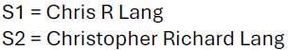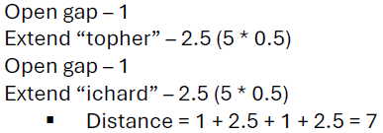
Smit-Waterman Distance: Beginning and end mismatches- < weights; ignored.
Token Based Similarity:
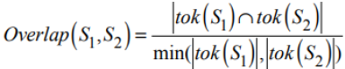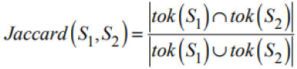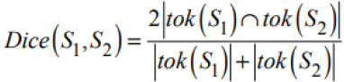
Phonetic Similarity:
(1) - Keep the first letter of the surname and ignore all occurrences of W and H (Peter – P) (2) - Assign following codes: (B, F, P, V = 1), (C, G, J, K, Q, S, X, Z = 2), (D, T = 3 ), (L = 4), (M, N = 5), (R = 6) (Pe3e6) (3) - A, E, I, O, U and Y are not coded and serve as separators (0) (P0306) (4) - Consolidate sequences of identical codes by keeping only the first occurrence (P0306) (5)- Drop separators (P36) (6) -Keep the letter prefix and the three first codes, padding with zeros if there are fewer than 3 codes (P360)
Entropy based binning:
Find the binary split boundary that minimizes the entropy function over all possible boundaries:
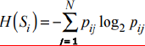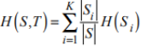
  - Greater the gain: better the split
Binning:
Divide the range of continuous attributes into intervals.
Equal width binning: n intervals of equal size
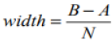
Equal depth binning: same number of samples in each interval
Class True Positive Rate:
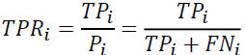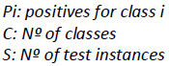
Global TP Rate weighted = Acc
Global TP Rate macro = BAcc
Global TP Rate micro = Acc
Class False Positive Rate: Global FP Rate w:
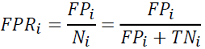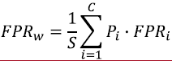
Global FP Rate ma: Global FP Rate mi:
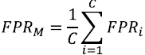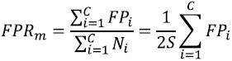
Class Precision: Global Precision w:
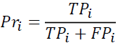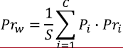
Global Precision ma: Global Precision mi = Acc
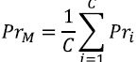
Class Recall: All Global Recall = Acc
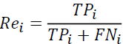
Class F1-Score: Global F1 w:
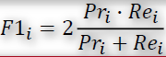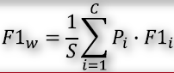
Global F1 ma: Global F1 mi = Acc
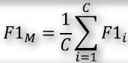
Error Rate (tudo menos diagonal):
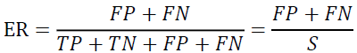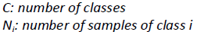
Accuracy (diagonal): Balanced Accuracy:
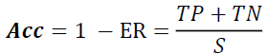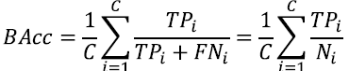
Fisher Score:
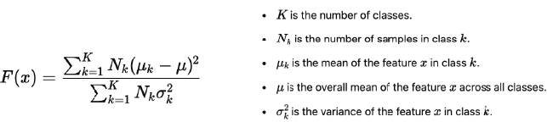
Confusion Matrix:
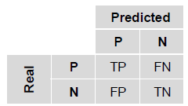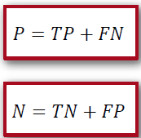
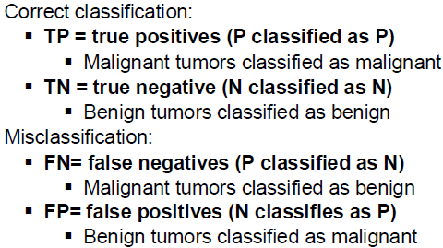
PCA:
- Centralizar usando z-score. – Achar a matriz de co-variância, para conseguir achar os eigenvalues e os eigenvectors. – Ordenar eigenvalues e consoante essa ordenação, ordenar os eigenvectors. – Projetar na matriz original (matrizO x eigenvectors ordenados)
Explained Variance: 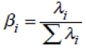
SMOTE – Oversampling Technique:
K-Nearest Neighbors:
- Calcular distância entre um ponto e todos os outros. – Selecionar os k pontos mais próximos. – Para classificar, entre os k, ver a classe que existe em maioria.
Z-Score:
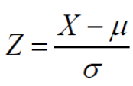, 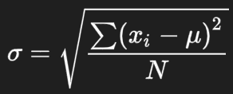 |Z| > k = outlier
Continuous-Continuous:
Pearson’s Correlation if normally distributed:
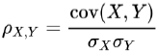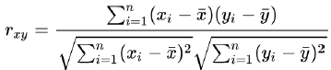
Spearman correlation (works with ranks) if not:
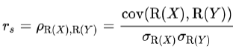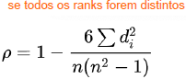
Categorical-Categorical:
Goodman Kruskal Lambda:
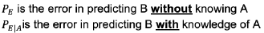
- without knowing A: - knowing A:
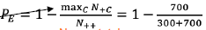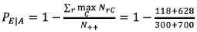
Chi Square:
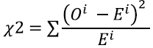 , 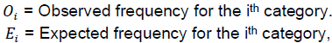
- 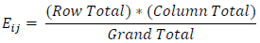
Continuous-Categorical:
2 classes: t-Test (normally distributed), Mann-Whitney U Test (one is not normally distributed)
More than 2: ANOVA, Kruskal-Wallis
